Name: Nooreldeen Ayman Mohammed Elmobashar
ITI Mansoura – Open Source
Mongo – Lab 2

___________________________________________________________________________

1. Find a book by its title "Microservices Architecture".

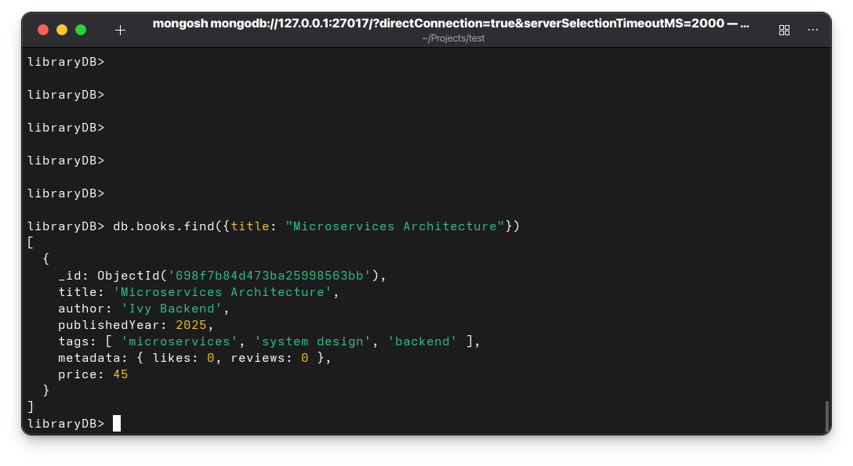
2. Find a book published in 2023 using findOne().
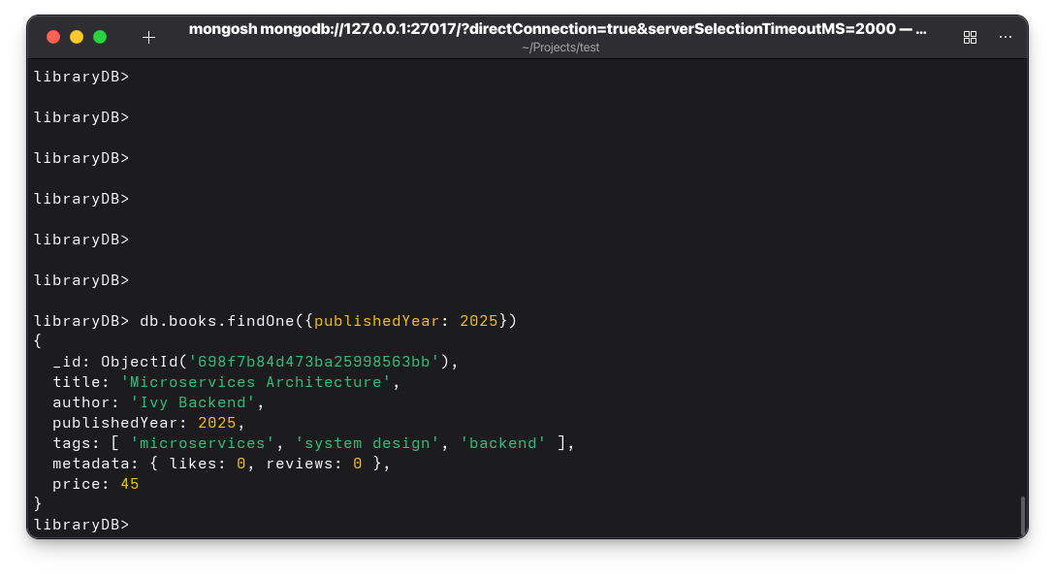

3. Find books cheaper than $35.

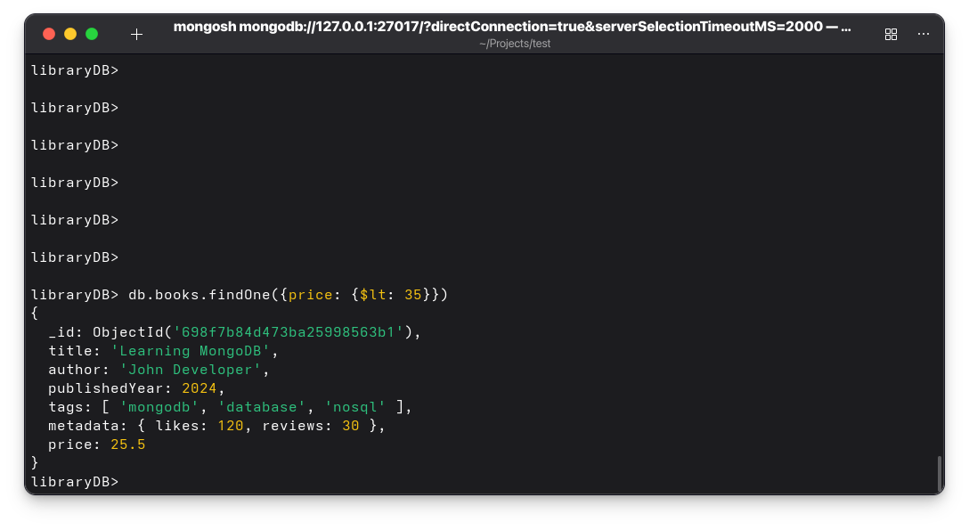
4. Find Books that have a metadata.likes value of type number
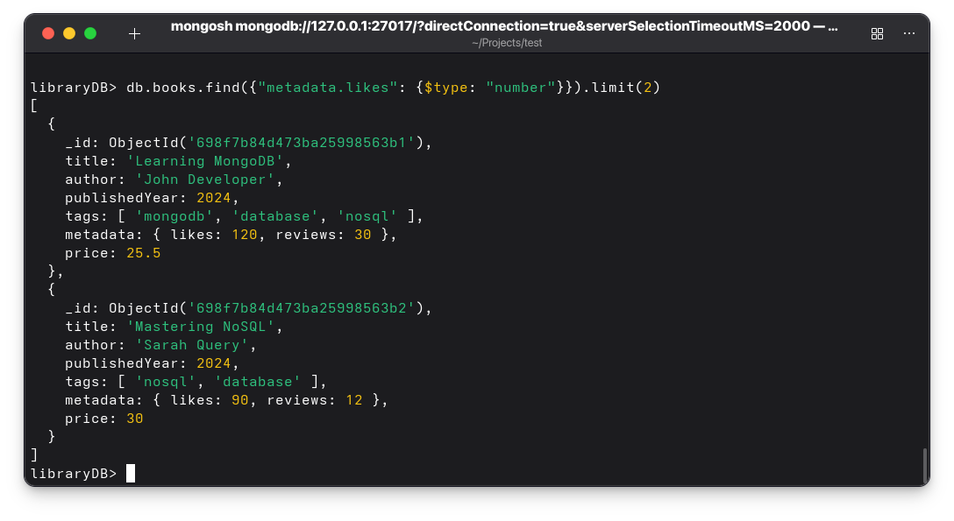
5. Find Books where tags is stored as an array
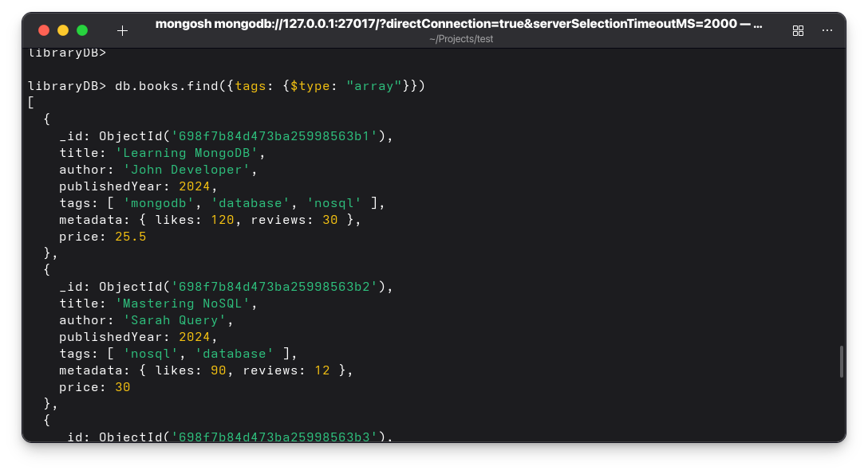
6. Find Books where the discount field does NOT exist
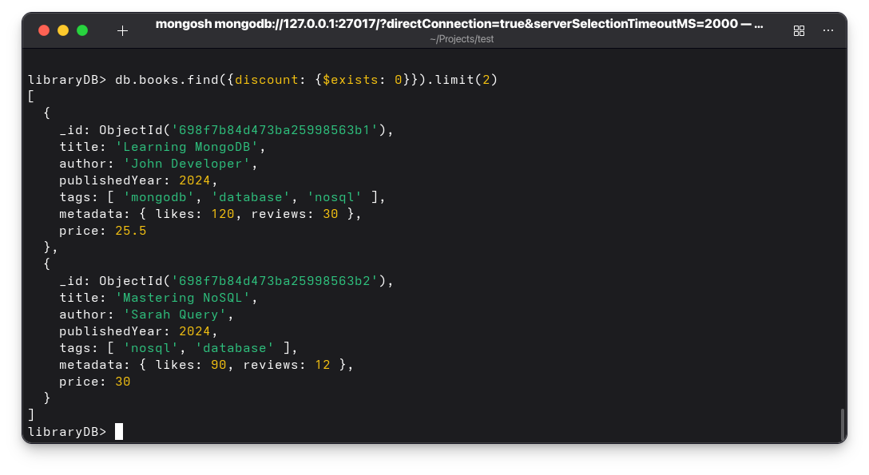
7. Update the price of "Microservices Architecture" to $50.
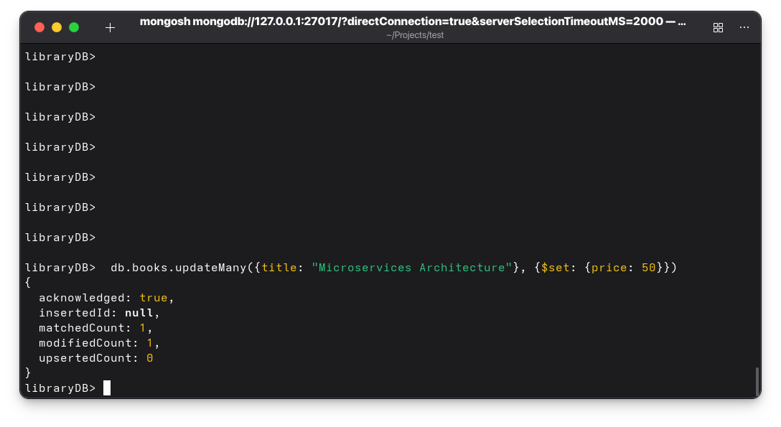
8. Update the author of "Python Programming" to "Alice Code Jr.".
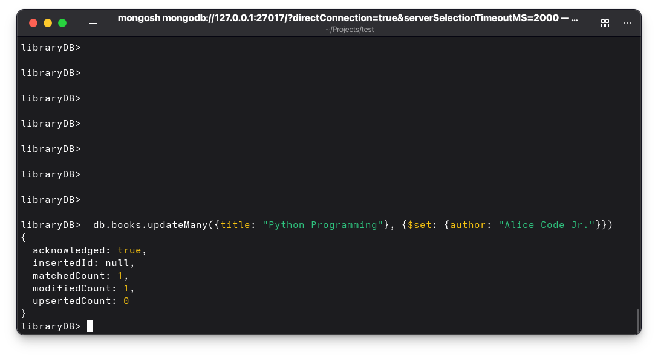
9. Delete a book with title "DevOps Fundamentals".
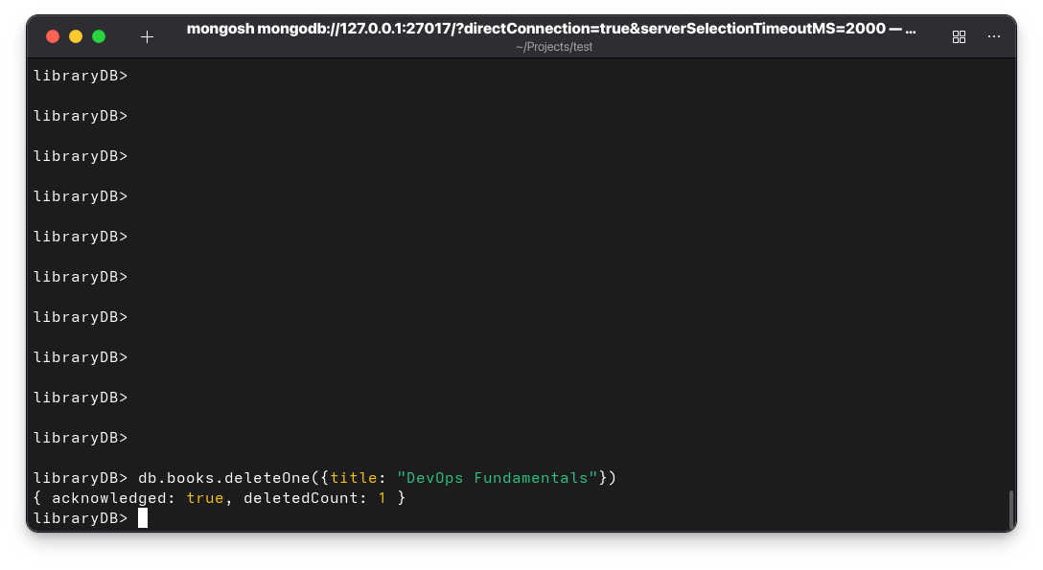
10. Delete all books published before 2021.
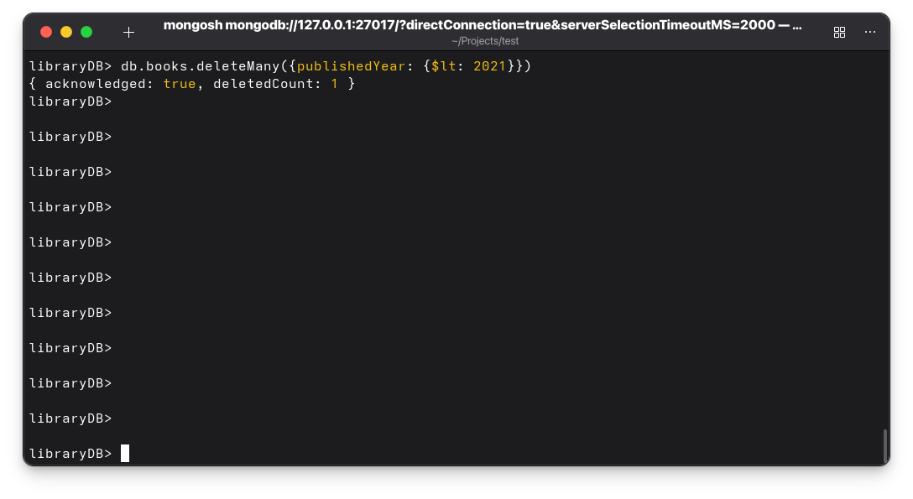

11. Sort by publishedYear descending and get the first 3 books

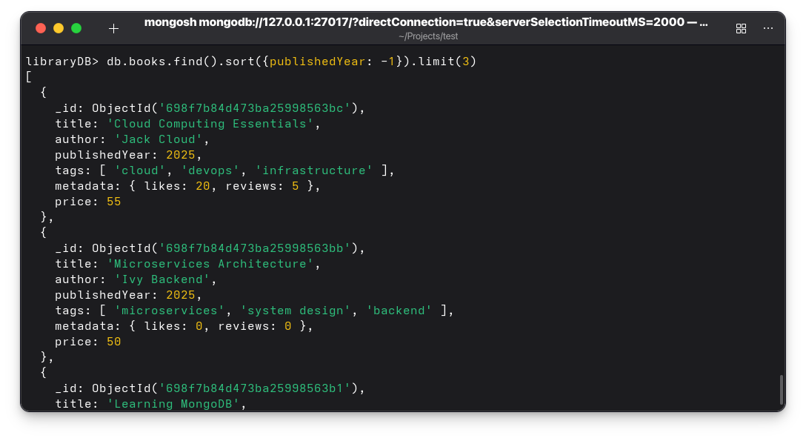

Embedded Documents Operations

12. Find books where metadata.likes > 100.

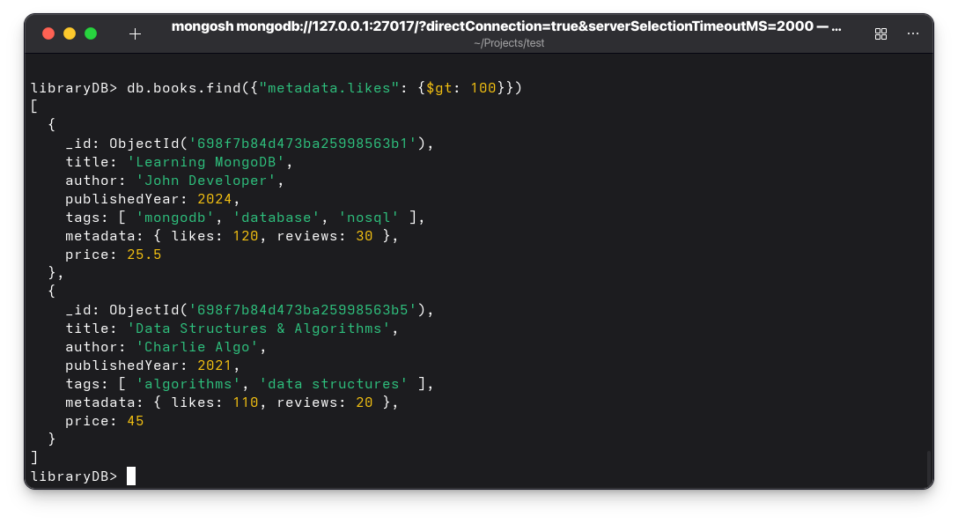
13. Find books where metadata.reviews >= 10 and metadata.likes < 100.
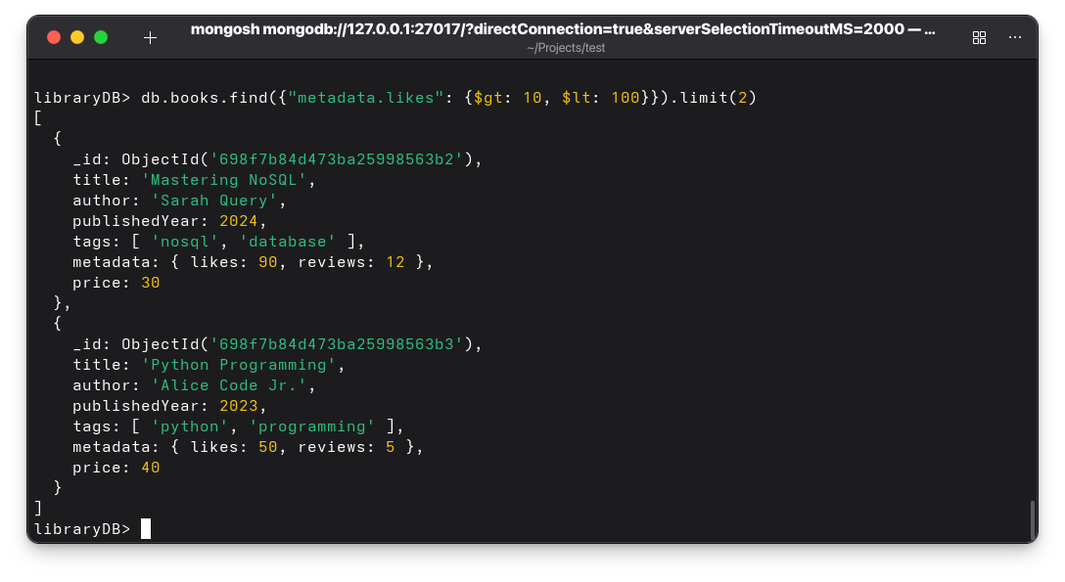
14. Increment metadata.likes of "Learning MongoDB" by 10.
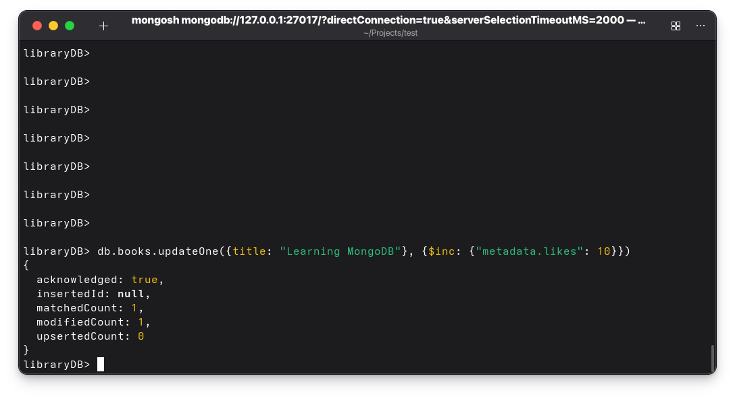
15. Add a new field metadata.shares with value 0 to all books.
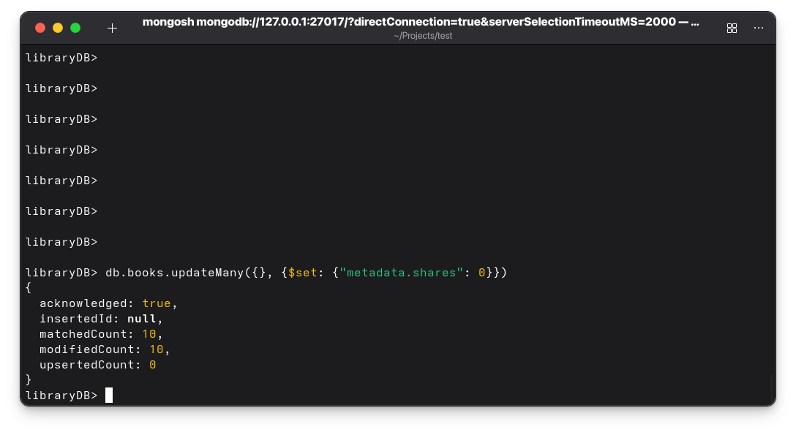
16. Rename metadata.reviews to metadata.reviewCount in "Advanced JavaScript".
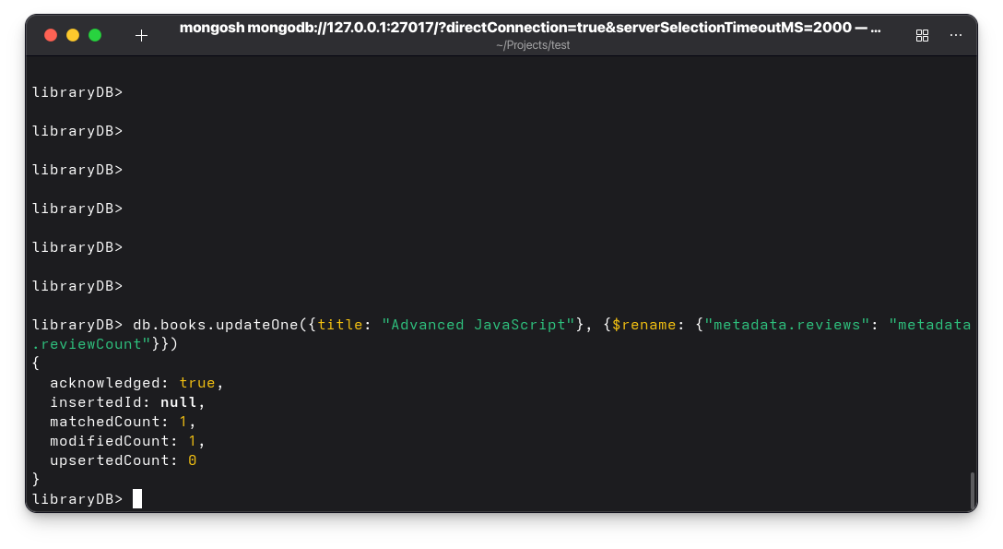

17. Remove the metadata.likes field from "Database Design".

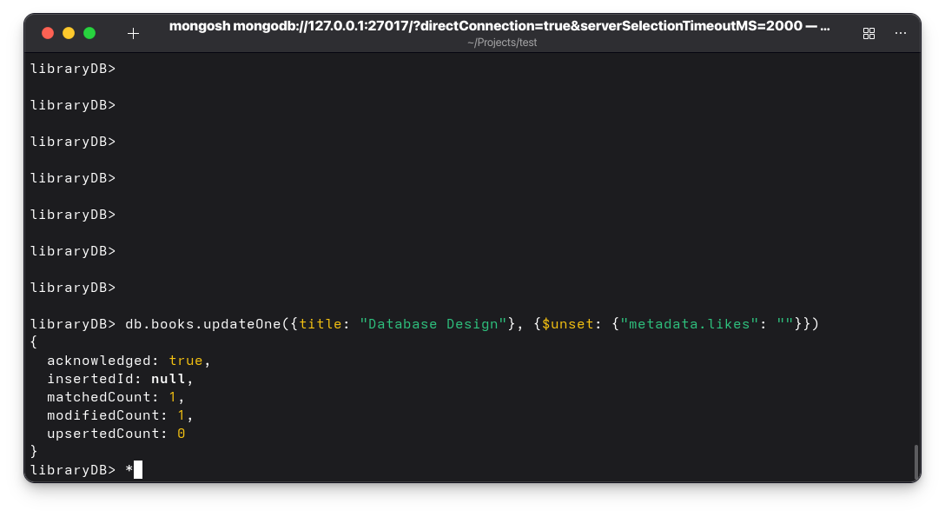

Array Field Operations

18. Find books where tags includes "javascript".

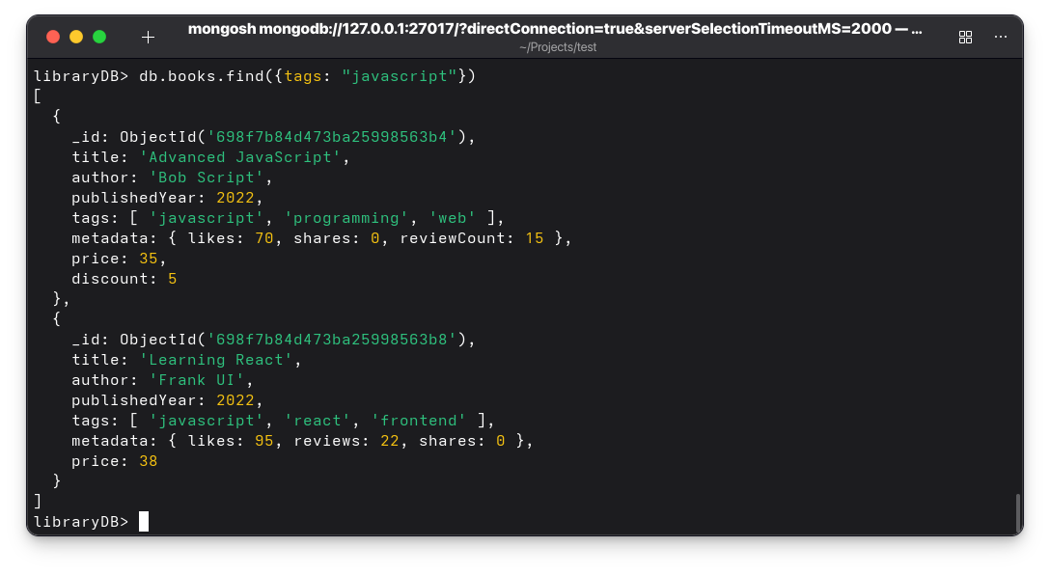
19. Find books where tags include both "mongodb" and "database".
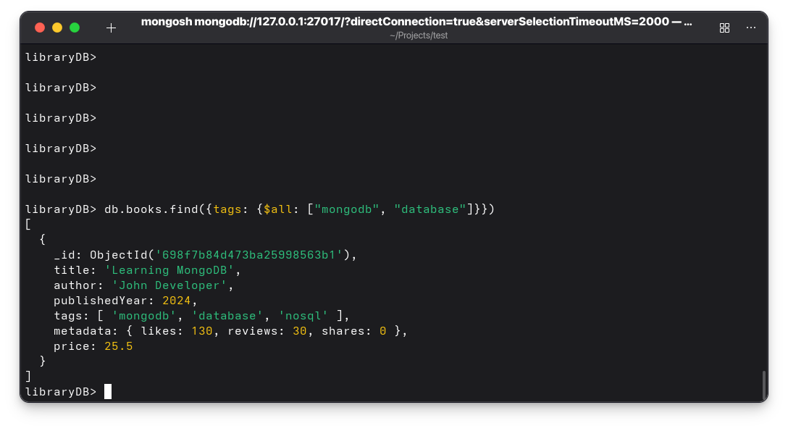
20. Find books where the first tag is "nosql".
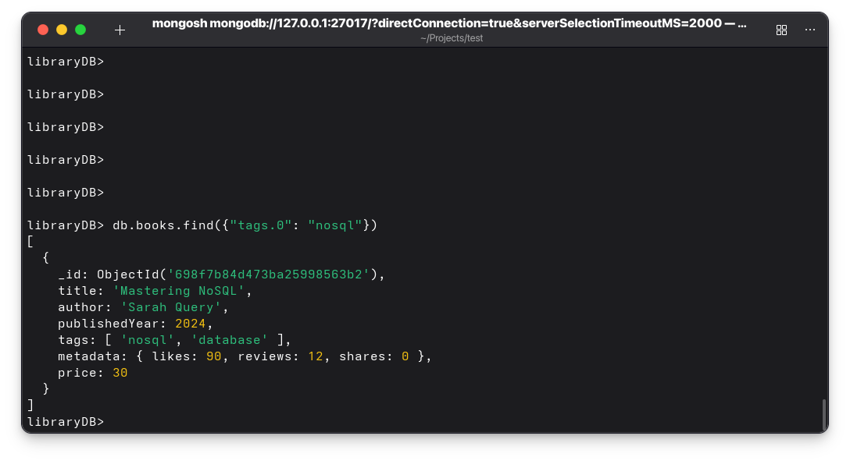
22. Add "programming" tag to "Learning MongoDB" if it doesn't exist.
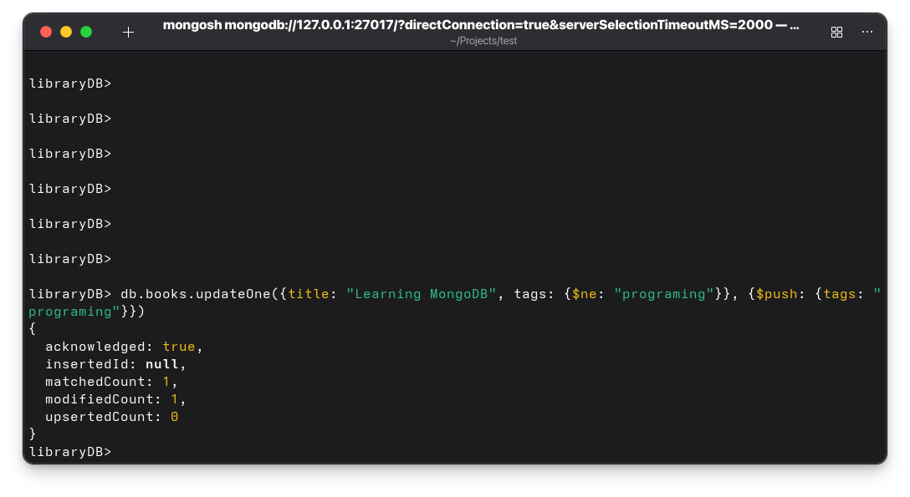

23. Remove "nosql" tag from "Mastering NoSQL".
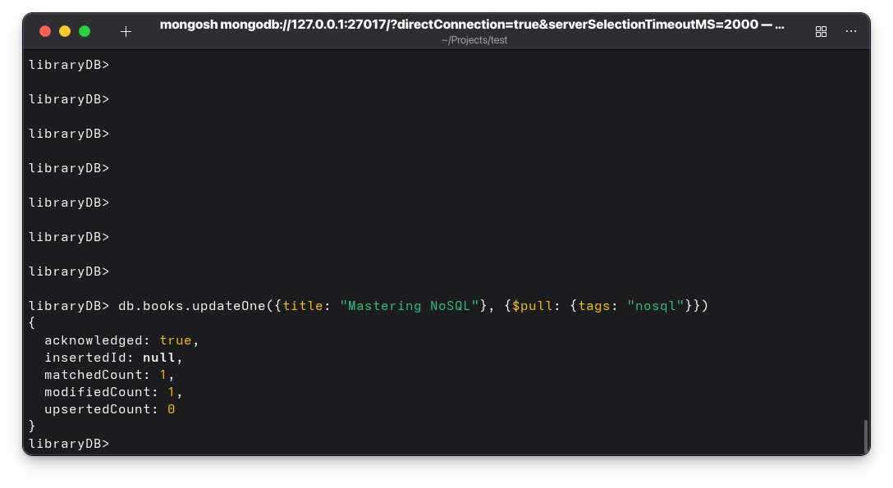
24. Update "python" tag in "Python Programming" to "Python 3".
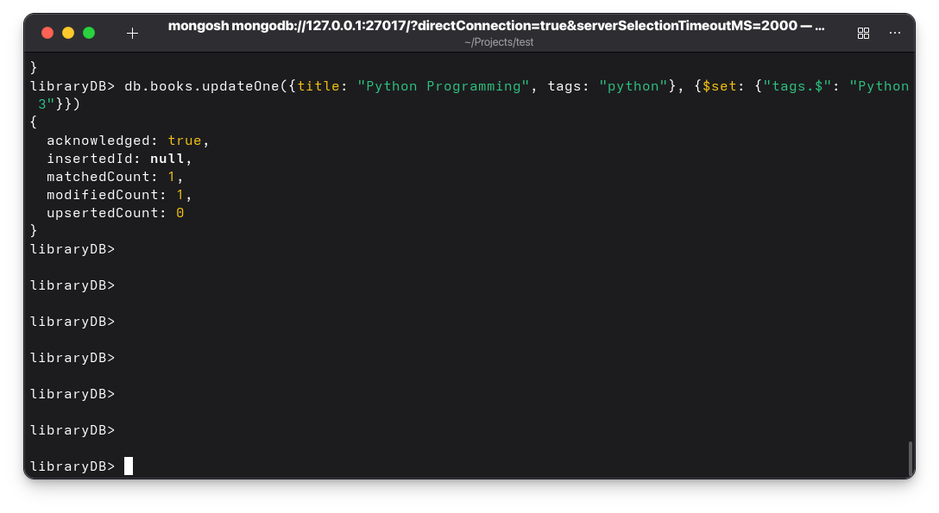
25. Push a new tag "bestseller" to all books published after 2023.

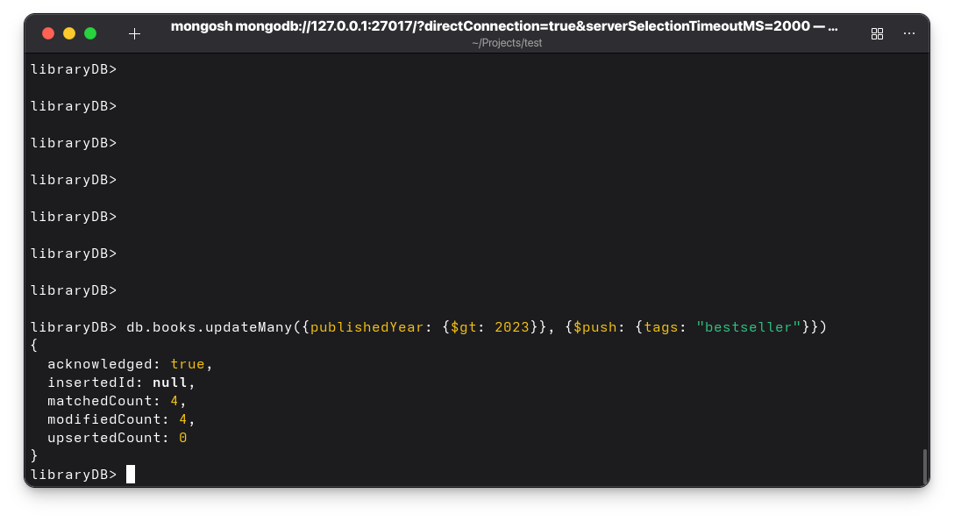
26. Pull "frontend" tag from books where it exists.
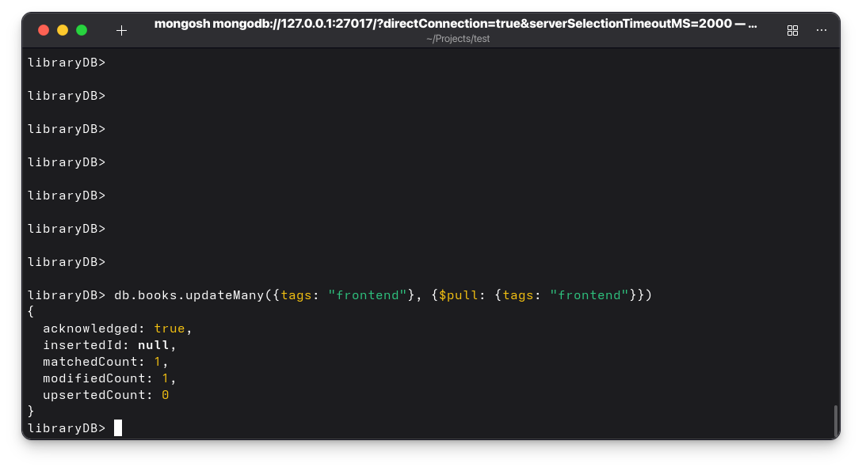
27. Add multiple tags at once: "cloud", "devops" to "DevOps Fundamentals".
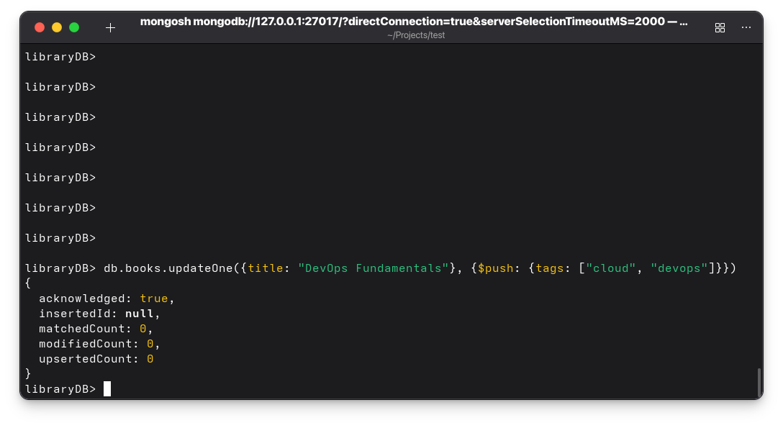

Combined Queries (Embedded + Array)

28. Find books where metadata.likes > 50 and tags contains "database".
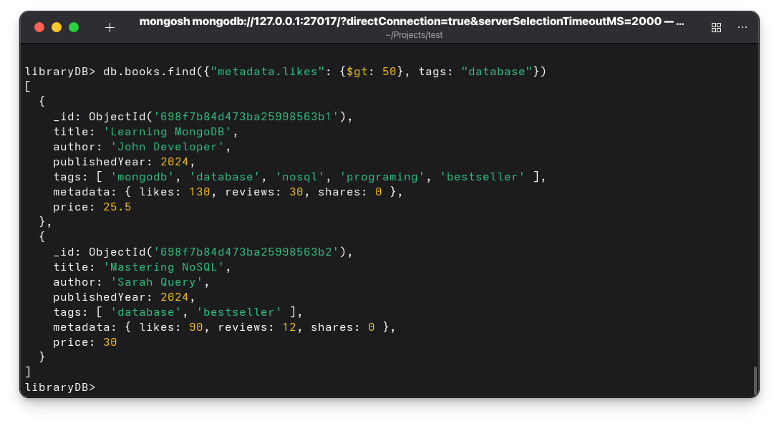
29. Increment metadata.likes by 5 only for books where tags include "nosql".
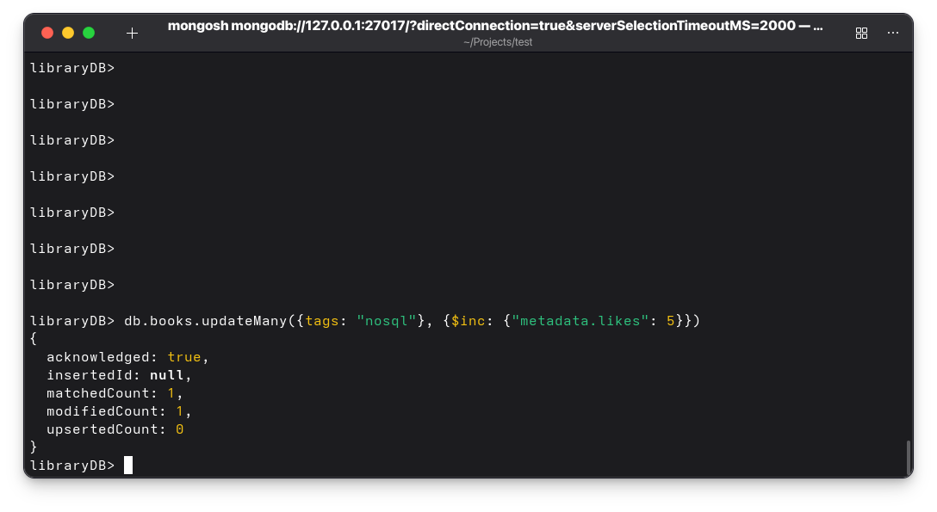
30. Find all books where tags is an array and metadata.reviews exists.
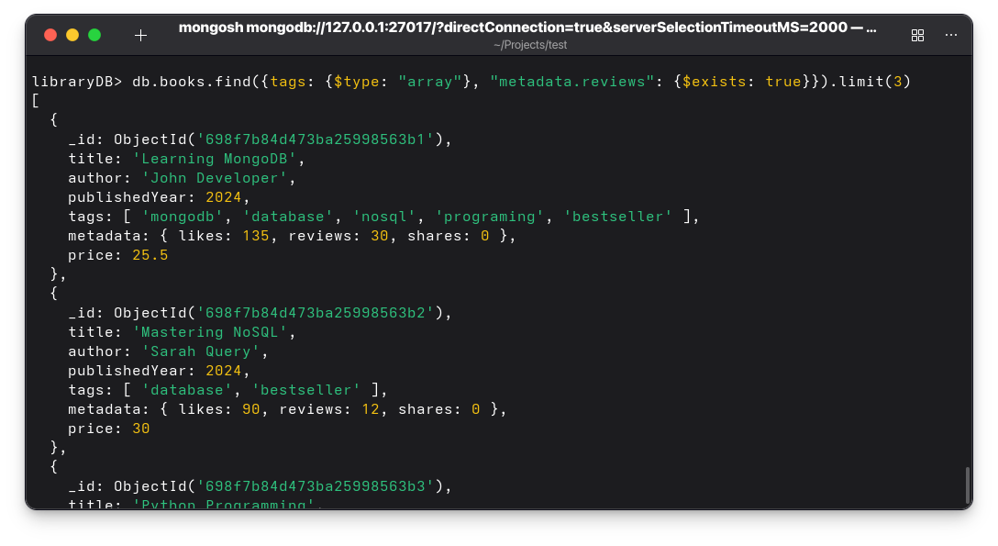
31. What is $elemMatch, $elemMatch vs $all?
$elemMatch Requires One element to meet all conditions
$all it ensures that all specified values exist somewhere within the array

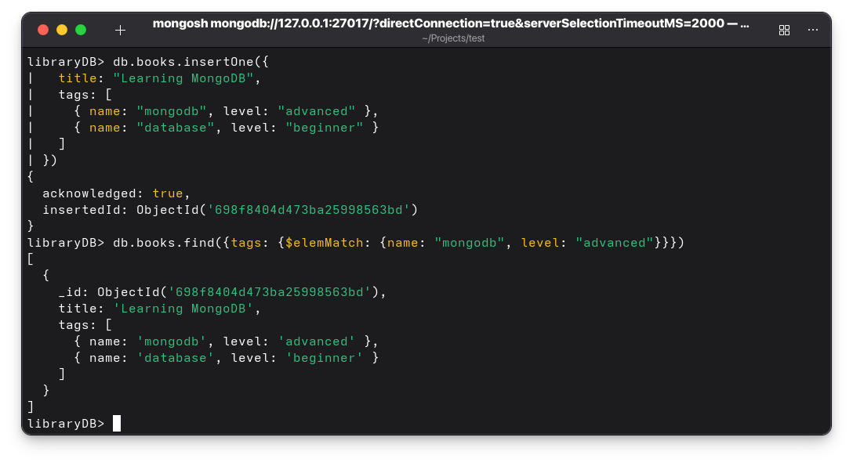
32. what difference addToSet VS push , pop vs pull
$push: Adds value to the array regardless of duplicates
$addToSet: Adds the value only if it does not already exists
$pop: Removes an element based on its position
$pull: Removes elements based on their value or a condition

